# Appendix A – Details of the Individual-Based Model (IBM)

This Appendix describes the equations and assumptions used to generate the length-at-age datasets used in the simulation testing component of this study. The first section describes the generation of the observed data, and the second component details further how spatial variation in fish size at age is introduced. Table A1 provides parameter values used in the study.

# A.1 Generation of age-length data

The IBM is designed to mimic individual variation in growth for an exploited fishery. The model runs for 100 years. Generally, all fish within each simulation are subject to the same baseline life history parameters, with three different growth “Regimes” (defined by distinct parameters of the growth equation, see below) assigned spatial ranges accordingly (see A.1.4 Assigning Spatio-temporal Variation, below).

## A.1.1. Growth

The growth module of the IBM is a von Bertalanffy growth function parameterized in terms of *L*1 and *L*2:

= App. Equation 1

where represents the lengths of a fish at ages , and *K* is the growth coefficient. The size of an individual *i* at age *a* is defined by its length in the previous year and a growth increment *I* that is lognormal:

App. Equation 2

where ) and = 0.025 for all ages and simulation Regimes.

## A.1.2 Survival

The composition of the fishery during year *y* includes all surviving fish from recruitment to a maximum age (represented here as a plus group ). After recruitment, all fish are subject to natural mortality *M*, which in our simulation consists only of natural mortality (set to 0.25 for all ages for all years) as there is no fishery, thus fishing mortality (typically denoted *F*) and selectivity can be ignored. Because no fishing pressure nor selectivity acted upon the simulated population, we are unconcerned about variation in growth that can either be engendered (over time) or misrepresented by differences in selectivity.

App. Equation 3

## A.1.3 Recruitment

Recruitment in the IBM is governed by a Beverton-Holt stock-recruitment function (Beverton and Holt, 1957), and a size-based maturity ogive which determines the probability of individual *i’*smaturity at age *a*, . Recruitment in a given year *Ry*is the sum of the product of the maturity ogive and empirical weights of each individual in that year, which is governed by a deterministic exponential length-weight relationship (**Error! Reference source not found.**). The parameters of this relationship were the same in all Regimes. The maturity ogives were also fixed for all regimes, with (the length at 50% maturity) 143.68cm, and the slope of the ogive at -0.1034.

happens at a midway point, and is subject to variation via a bias-corrected lognormal recruitment deviation

App. Equation 4

App. Equation 5

App. Equation 6

App. Equation 7

App. Equation 8

# A.1.4 Assigning Spatio-temporal Variation

The simulation testing component required generation of datasets that comprised variation in fish size-at-age across space and/or time. To obtain spatial variation in length-at-age, we conducted simulations using one of three growth “regimes” (see **Error! Reference source not found.**). Parameters for Regime 1 are similar to Pacific billfish; values for Regimes 2 and 3 were chosen to present either high or low contrast (respectively) in the size at maximum age compared to Regime 1. Other parameters were held constant across regimes. Spatial scenarios tested are described in the main manuscript, Table 1. In all except the final (break-at-edge) and non-spatial scenarios, the latitude and longitude of fish grown under Regime 1 are sampled independently and at random from a uniform distribution between 0° and 25°; for simulations with spatial variation, fish grown under Regimes 2 and 3 have latitude and longitude sampled the same way from 25° to 50°. In the final scenario, fish simulated under life history Regime 1 are assigned latitudes and longitudes sampled independently and at random from a uniform distribution from 1° to 49°, and those simulated under Regime 2 have coordinates sampled similarly with both latitude and longitude bounded from 49° to 50°.

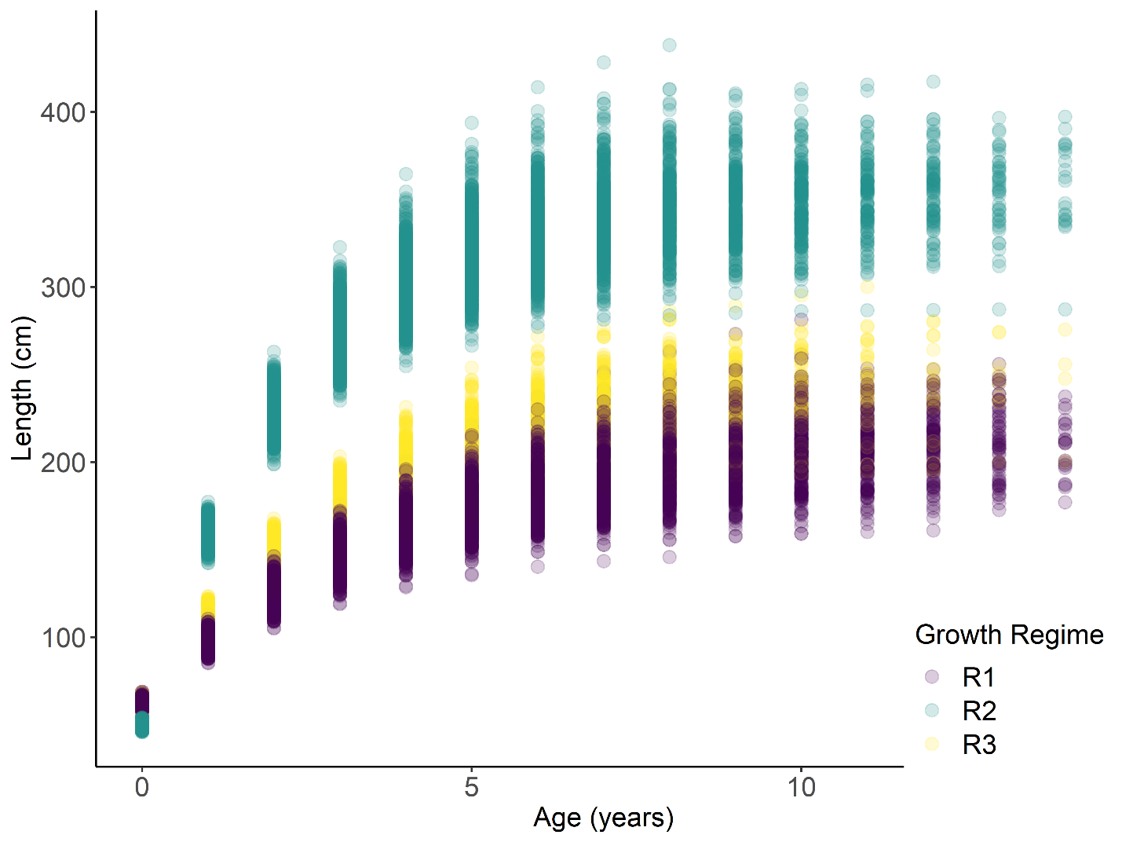

Figure A2. Example growth trajectories from simulated populations. Each circle represents a simulated individual fish’s length and age; colors correspond to the growth regime (i.e., growth curve) under which that fish was generated.

|  |  |  |  |
| --- | --- | --- | --- |
| Module | Parameter | Definition | Value |
| Growth |  | Size at age (cm) | 62.7 (Regimes 1, 3)  50 (Regime 2) |
| Growth |  | Size at age (cm) | 216.7 (Regime 1)  350 (Regime 2)  248 (Regime 3) |
| Growth | k | Growth coefficient | 0.258 (Regime 1)  0.45 (Regime 2)  0.3 (Regime 3) |
| Growth |  | Age at (years) | 0 |
| Growth |  | Age at (years) | 15 |
| Growth |  | Lognormal growth error term | 0.025 |
| Growth | *a* | Multiplier of length-weight function | 1.35e-6 |
| Growth | *b* | Exponent of length-weight function | 3.427 |
| Survival | *M* | Natural mortality | 0.25 |
| Recruitment | *r* | Slope of maturity ogive | -0.1034 |
| Recruitment | L50 | Length at 50% maturity | 143.68 |
| Recruitment | *h* | Steepness of Beverton-Holt SRR | 0.9 |
| Recruitment | *R0* | Maximum number of recruits per year | 12 |
| Recruitment |  | Variation in recruitment | 0.1 |

Table A1. Parameter symbols, definitions and values used in the simulation study.

# References

Beverton, R.J.H., Holt, S.J., 1957. On the Dynamics of Exploited Fish Populations, Fisheries Investigations Series 2: Sea Fisheries. https://doi.org/10.1007/BF00044132

Methot, R.D., Wetzel, C.R., 2013. Stock synthesis: A biological and statistical framework for fish stock assessment and fishery management. Fish. Res. 142, 86–99. https://doi.org/10.1016/j.fishres.2012.10.012

# Appendix B – Additional figures from the GAM-based analysis of sablefish size at age.

Figures A3 – A12 are identical in form to Figure 6 and 8 from the main manuscript, which presented results for age four female sablefish. These plots contain results for ages 6 and 30 for males and females, and age-four males. 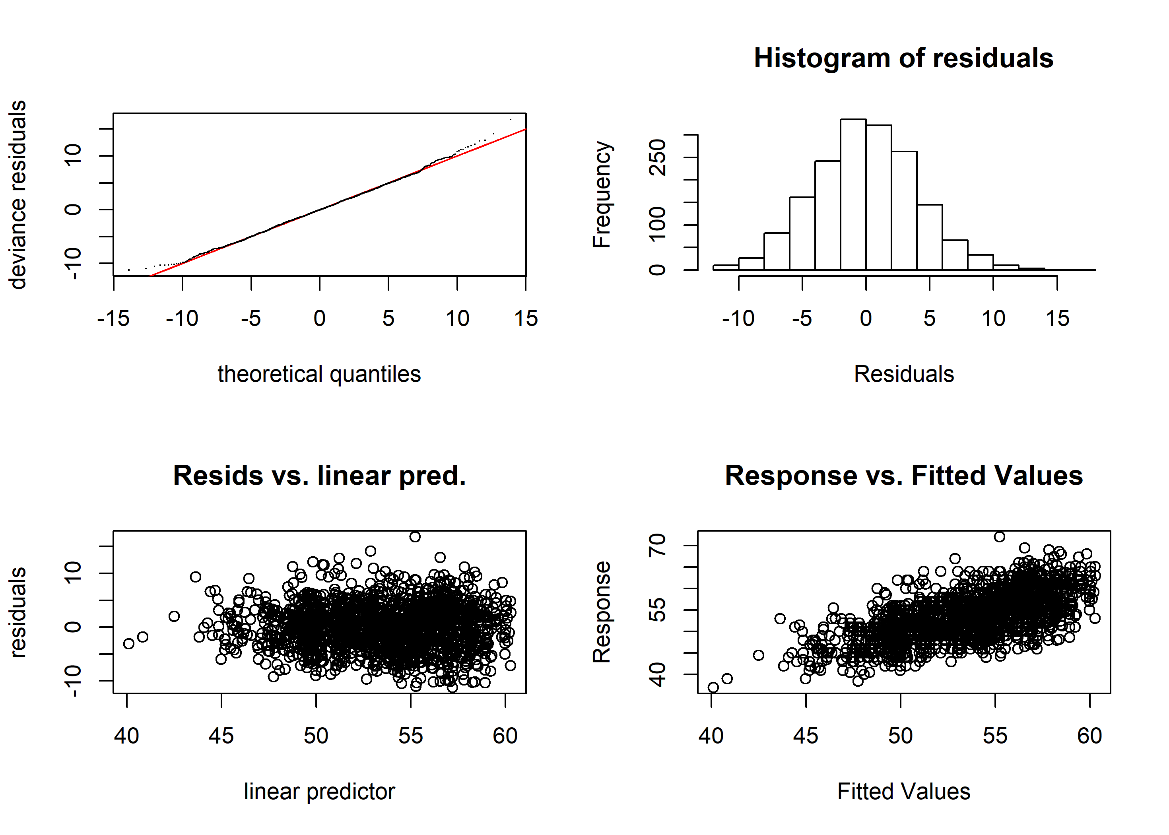

Figure A3 Diagnostic plots of best-fit GAM model for male age four sablefish. Clockwise from top left: quantile-quantile plot of deviance residuals; histogram of residuals; observed response values (lengths, in cm) vs predicted values, and model-predicted residuals vs linear predictor.

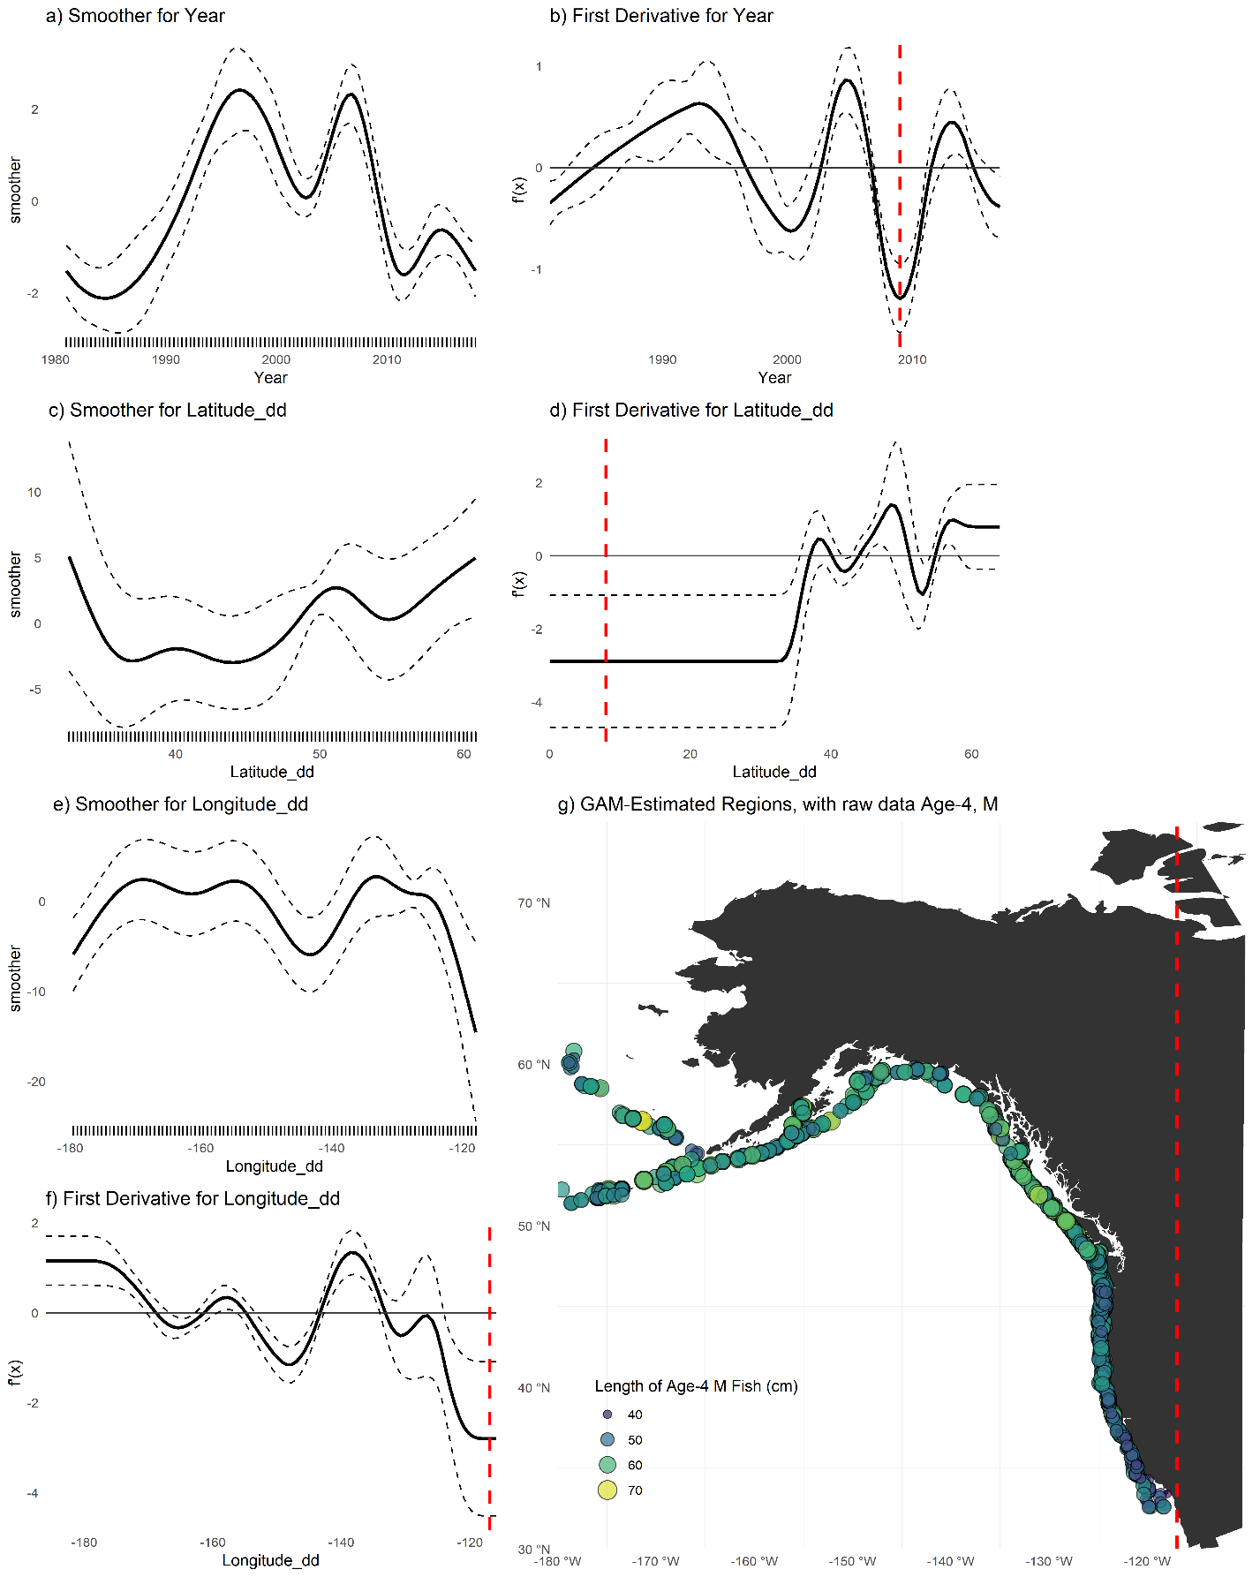

Figure A4 (a,c,e) Plots of smoothers for Year, Latitude, and Longitude, and first derivatives thereof for age-four male sablefish (b,d,f). Red lines indicate latitudes or longitudes that produced the highest first derivative and had a confidence interval that did not include zero. g) map with model-detected breakpoints (red lines).

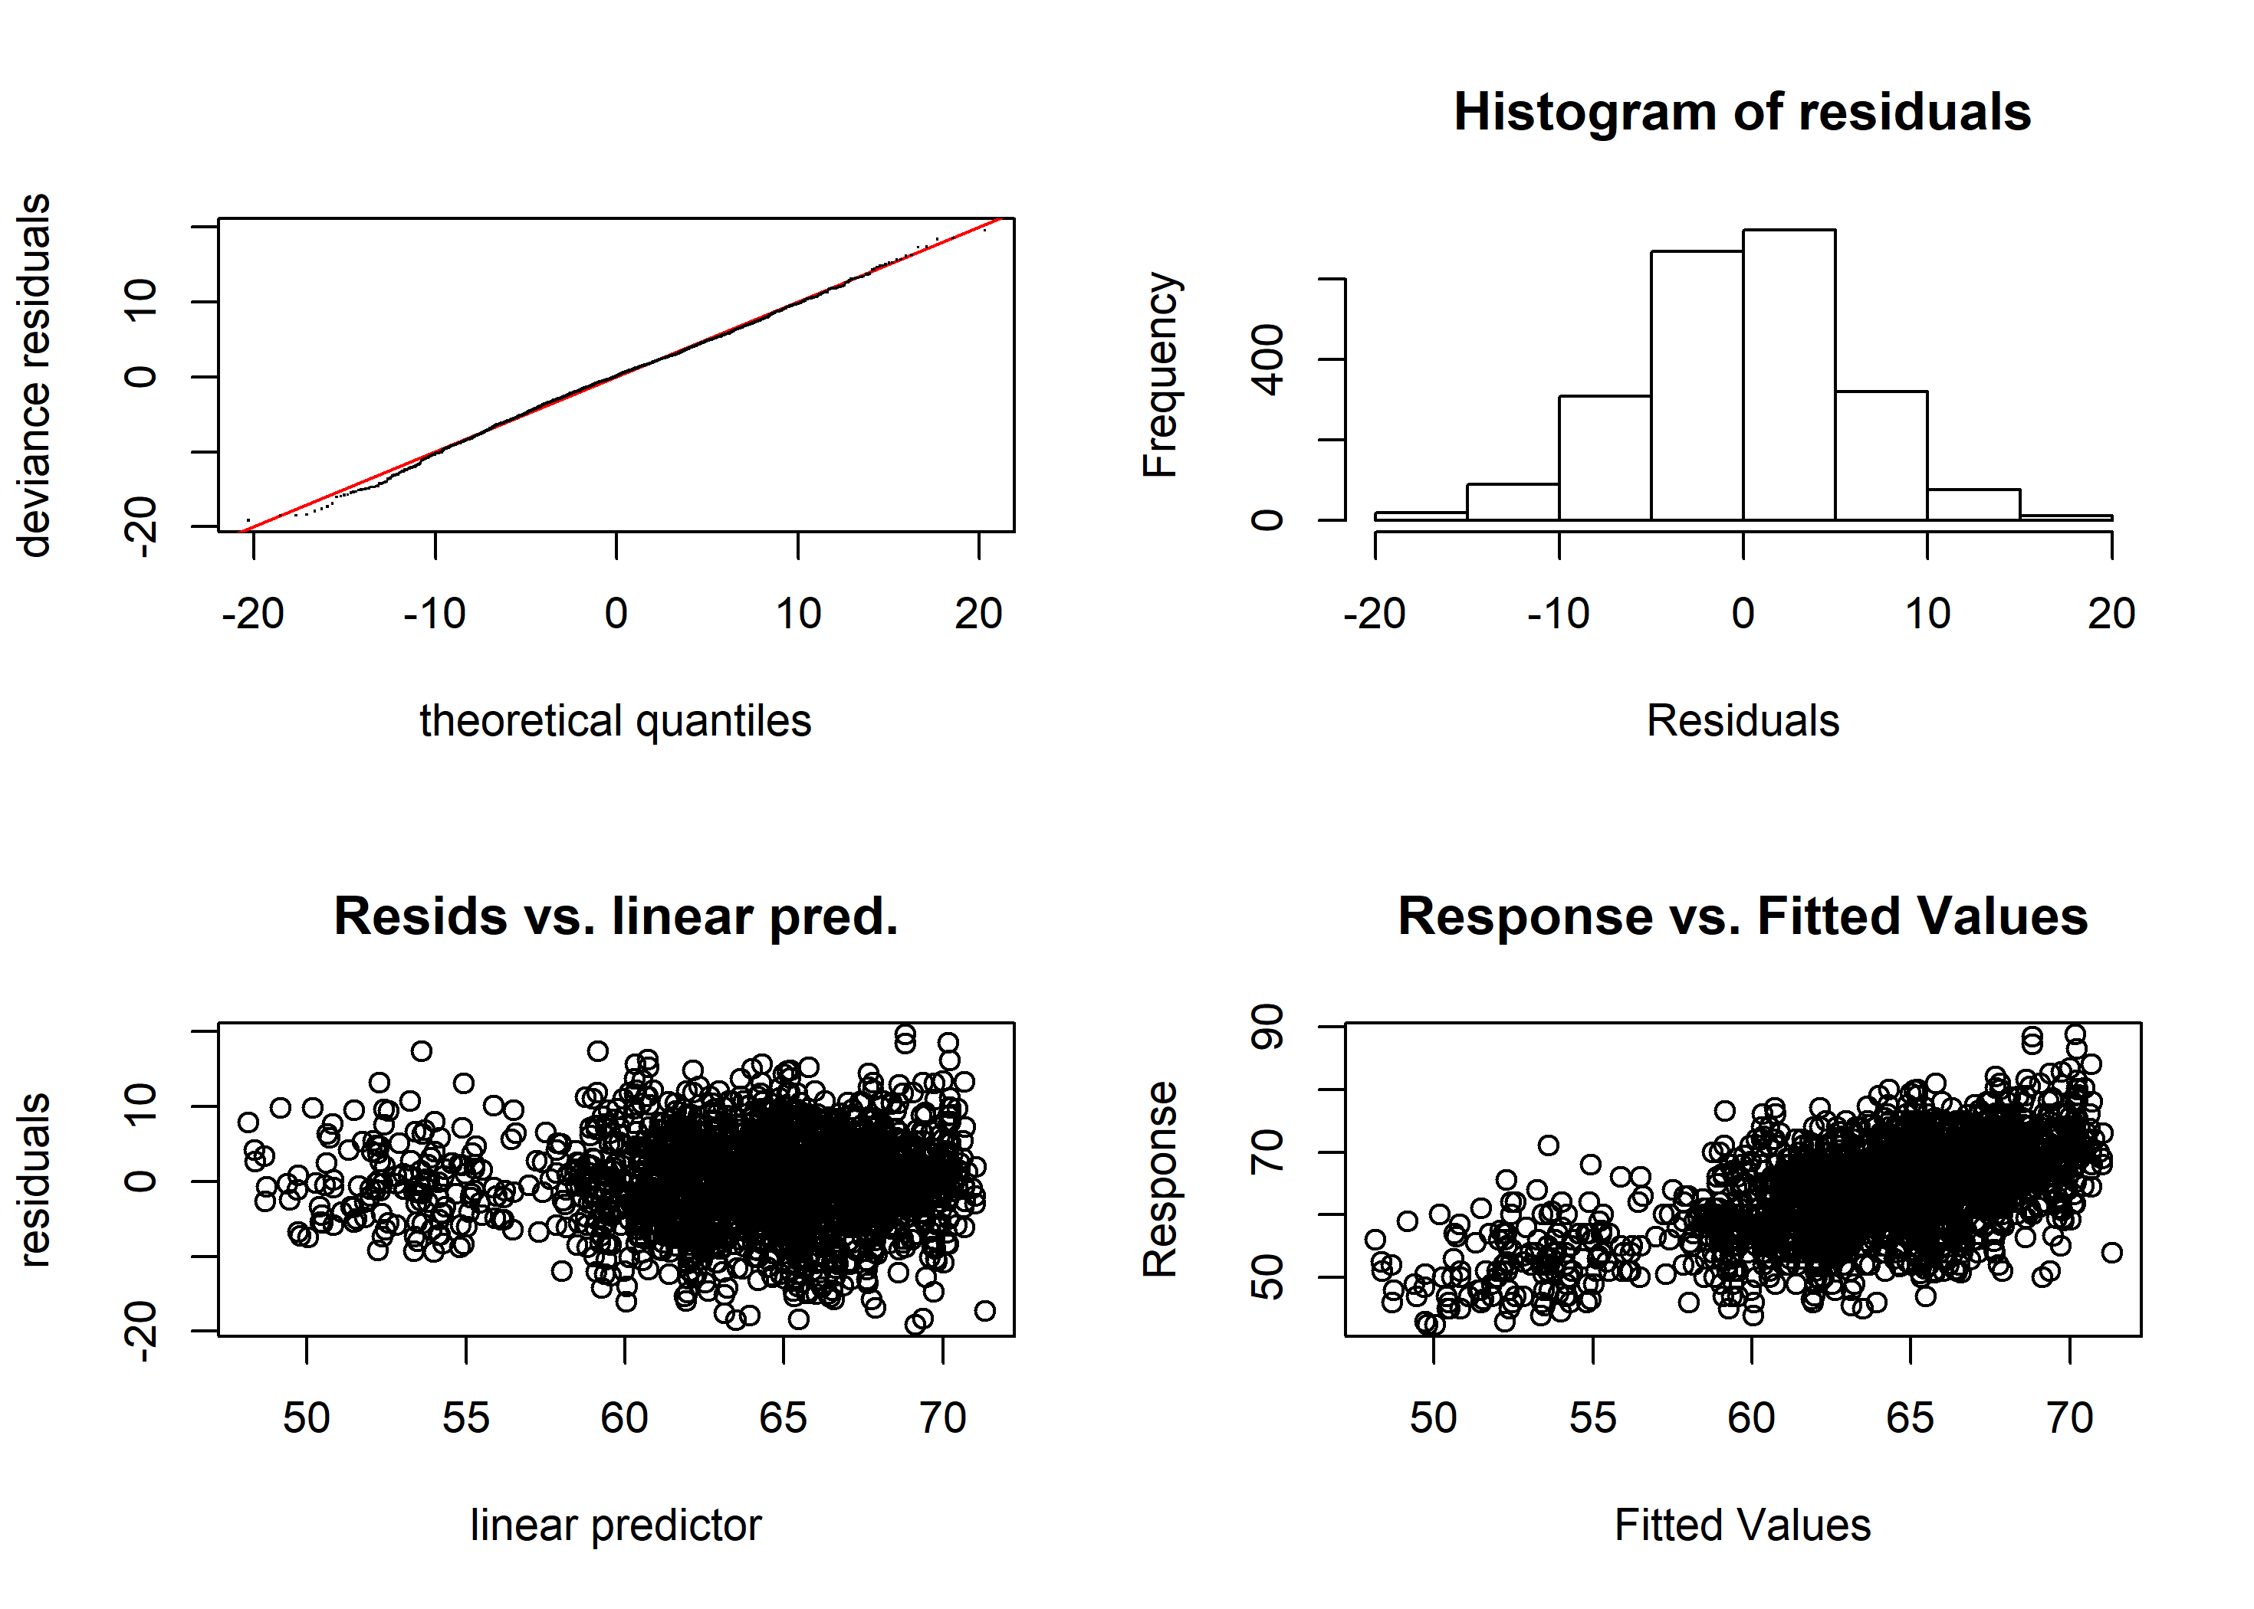

Figure A5 Diagnostic plots of best-fit GAM model for female age six sablefish. Clockwise from top left: quantile-quantile plot of deviance residuals; histogram of residuals; observed response values (lengths, in cm) vs predicted values, and model-predicted residuals vs linear predictor.

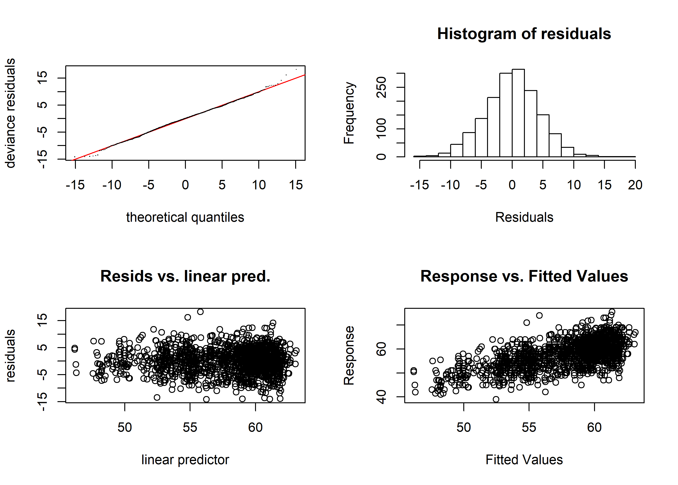 Figure A7 Diagnostic plots of best-fit GAM model for male age six sablefish. Clockwise from top left: quantile-quantile plot of deviance residuals; histogram of residuals; observed response values (lengths, in cm) vs predicted values, and model-predicted residuals vs linear predictor.

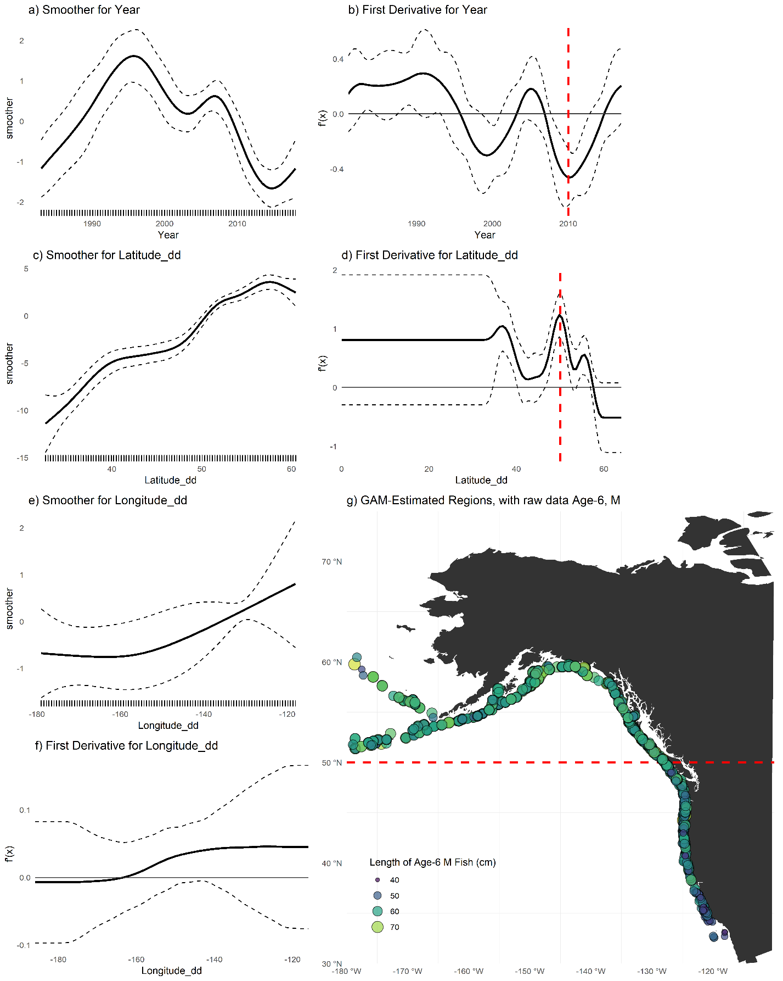Figure A8 (a,c,e) Plots of smoothers for Year, Latitude, and Longitude, and first derivatives thereof for male age six sablefish (b,d,f). Red lines indicate latitudes or longitudes that produced the highest first derivative and had a confidence interval that did not include zero.g) map with model-detected breakpoints (red lines).

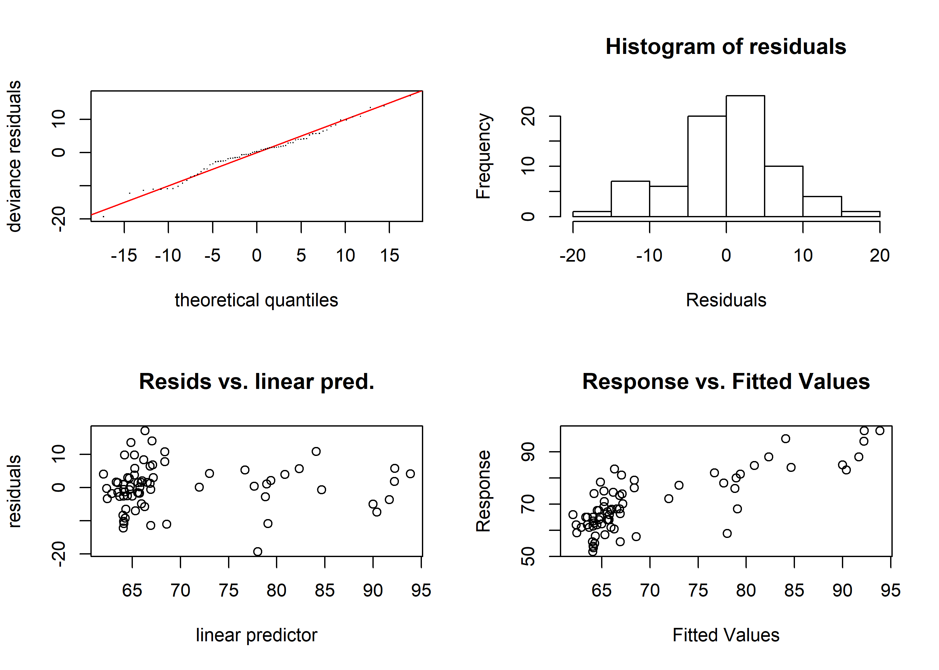Figure A9 Diagnostic plots of best-fit GAM model for female age thirty sablefish. Clockwise from top left: quantile-quantile plot of deviance residuals; histogram of residuals; observed response values (lengths, in cm) vs predicted values, and model-predicted residuals vs linear predictor.

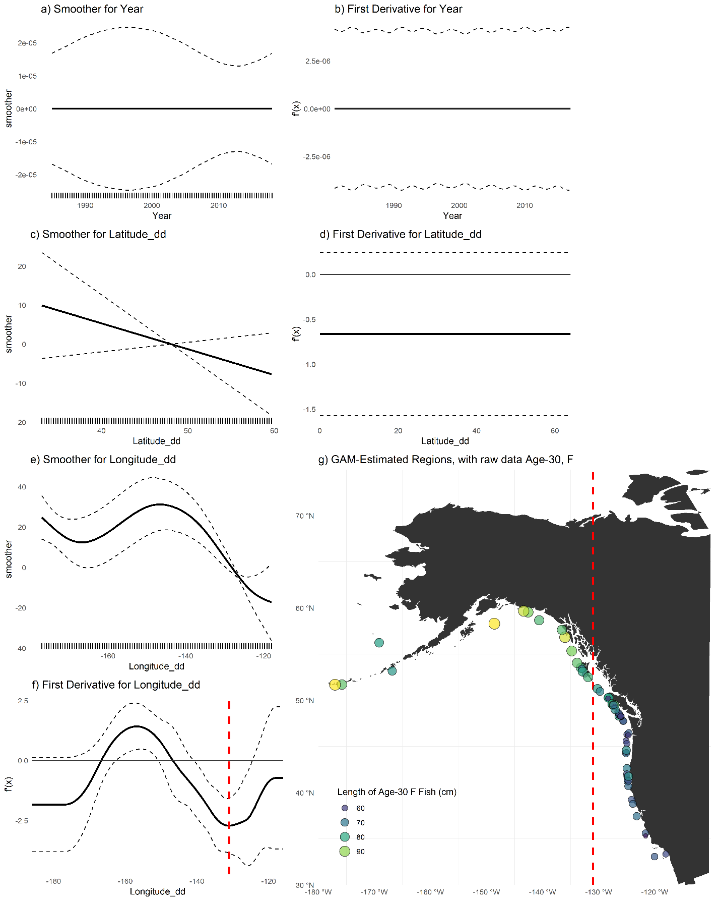Figure A10 (a,c,e) Plots of smoothers for Year, Latitude, and Longitude, and first derivatives thereof for female age thirty sablefish (b,d,f). Red lines indicate latitudes or longitudes that produced the highest first derivative and had a confidence interval that did not include zero.g) map with model-detected breakpoints (red lines).

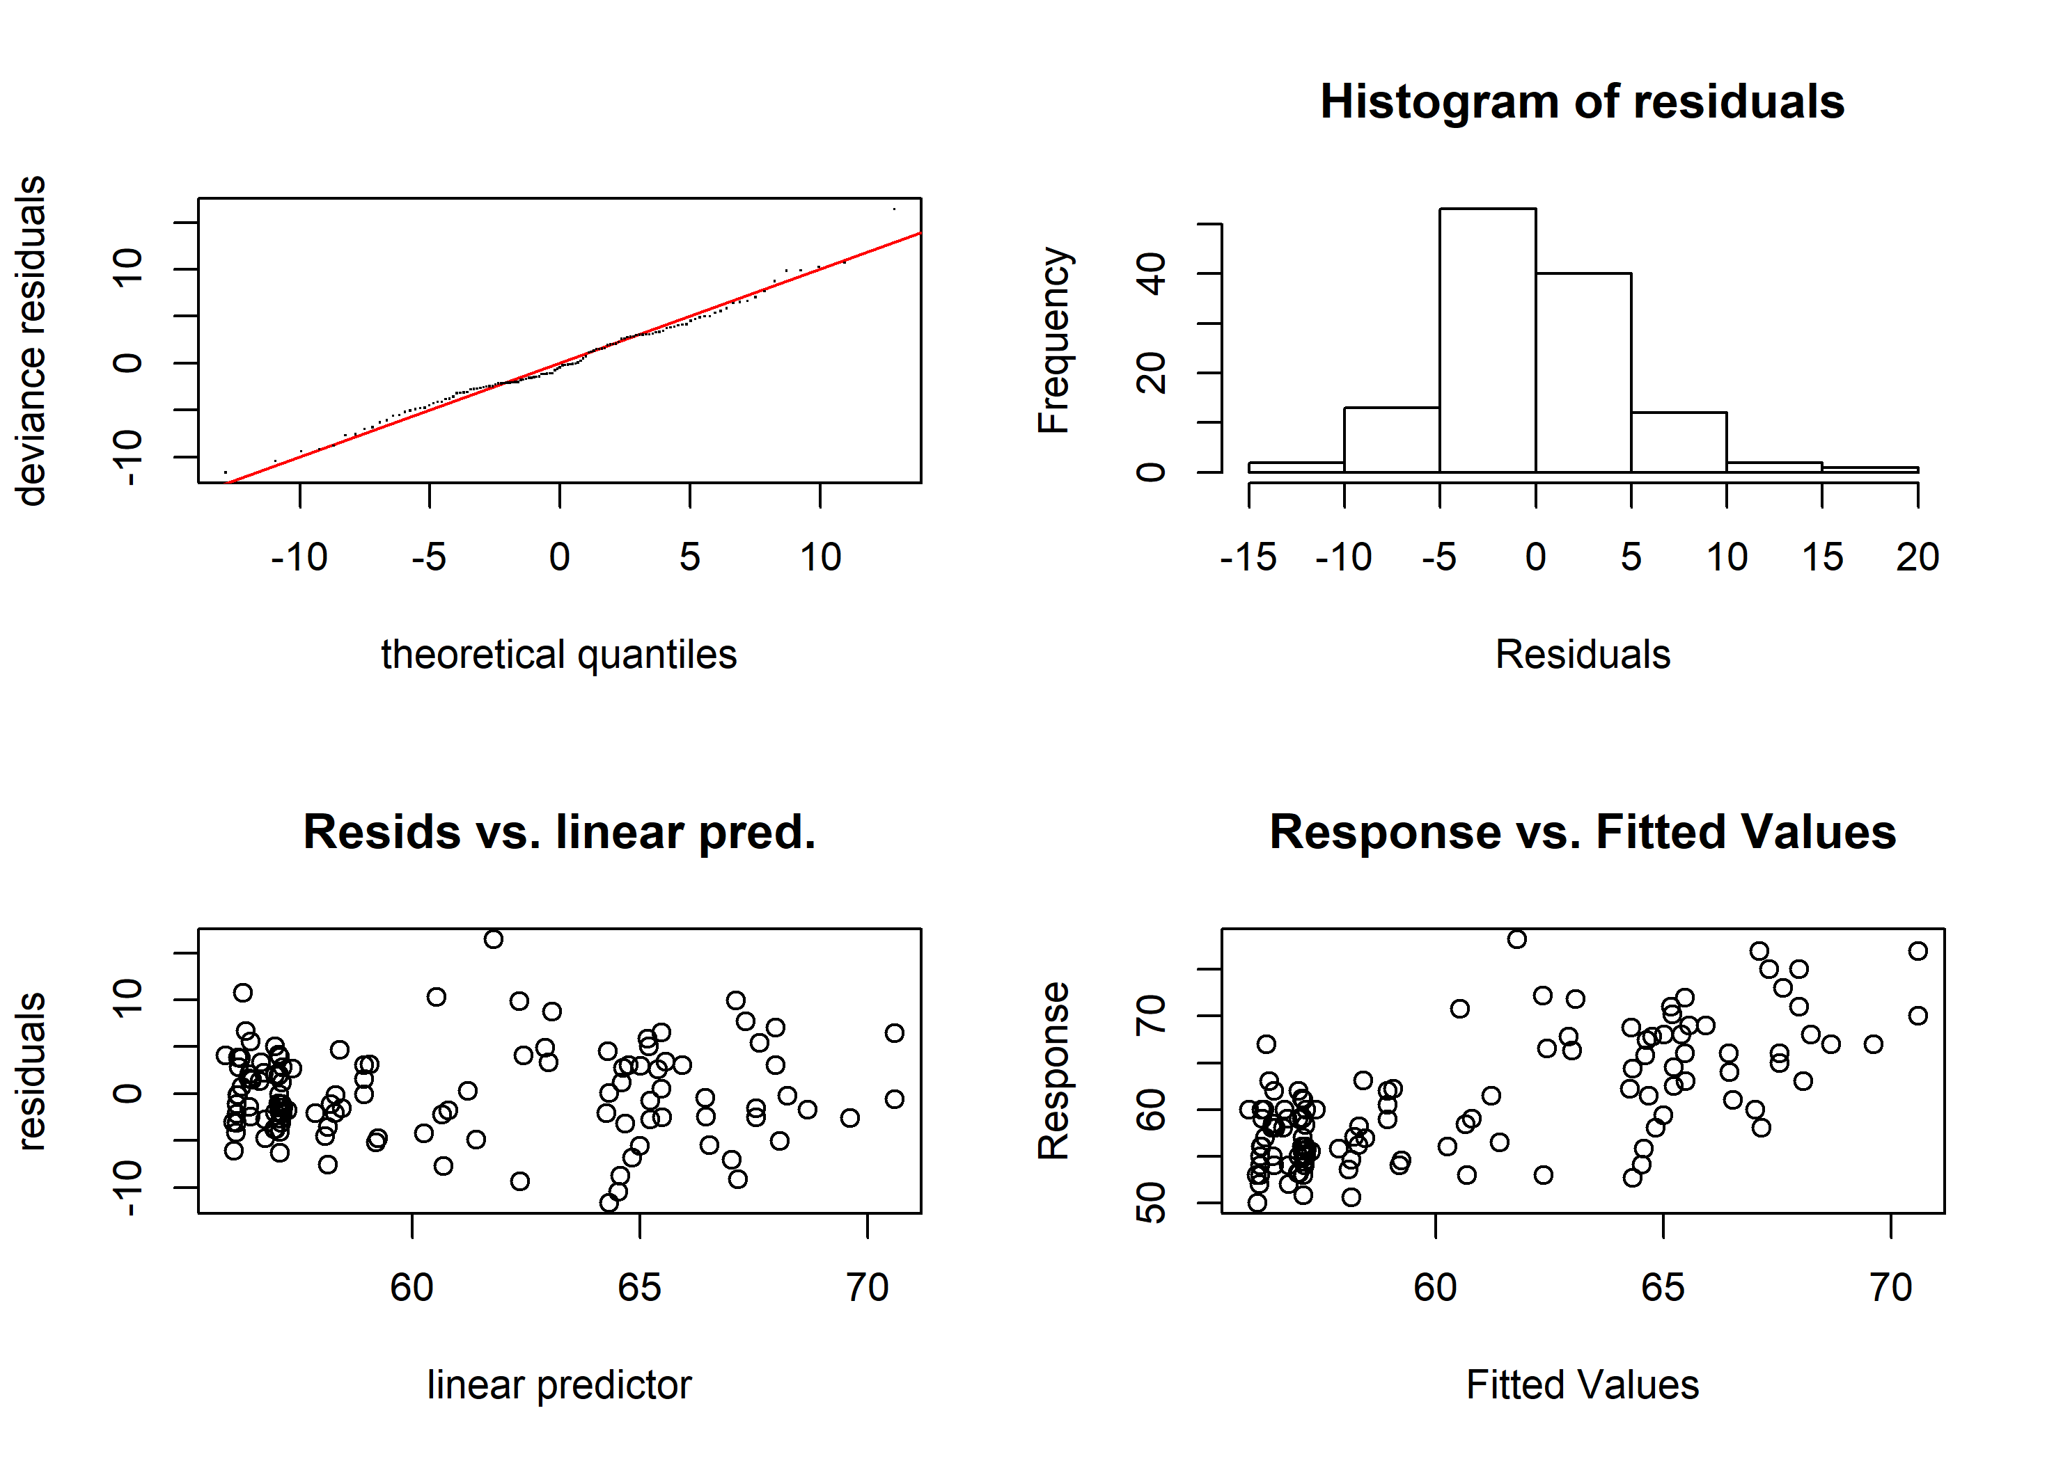Figure A11 Diagnostic plots of best-fit GAM model for male age thirty sablefish. Clockwise from top left: quantile-quantile plot of deviance residuals; histogram of residuals; observed response values (lengths, in cm) vs predicted values, and model-predicted residuals vs linear predictor.

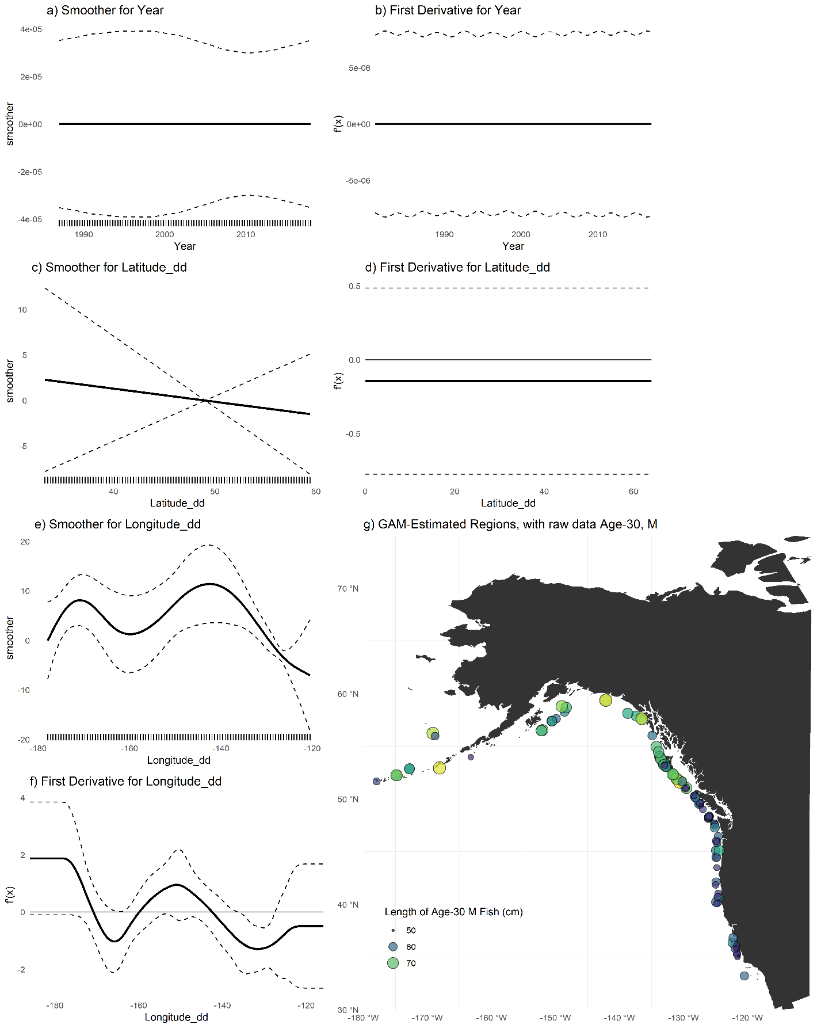Figure A12 (a,c,e) Plots of smoothers for Year, Latitude, and Longitude, and first derivatives thereof for male age thirty sablefish (b,d,f). Red lines indicate latitudes or longitudes that produced the highest first derivative and had a confidence interval that did not include zero. g) map with model-detected breakpoints (red lines).

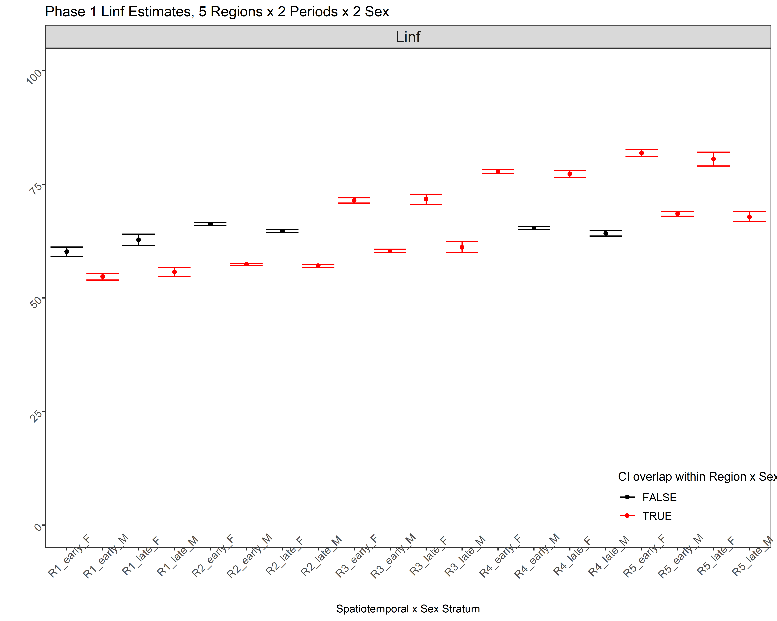

Figure A13 *L∞* estimates for for the fully stratified, 5-region, 2-period (during and after 2010, and before) and 2-sex model. Bars represent 95% confidence intervals. Strata from the same spatial region and sex which shared overlapping ranges for Linf are colored in red and early and late periods were combined within their respective regions and sexes for the subsequent analysis.

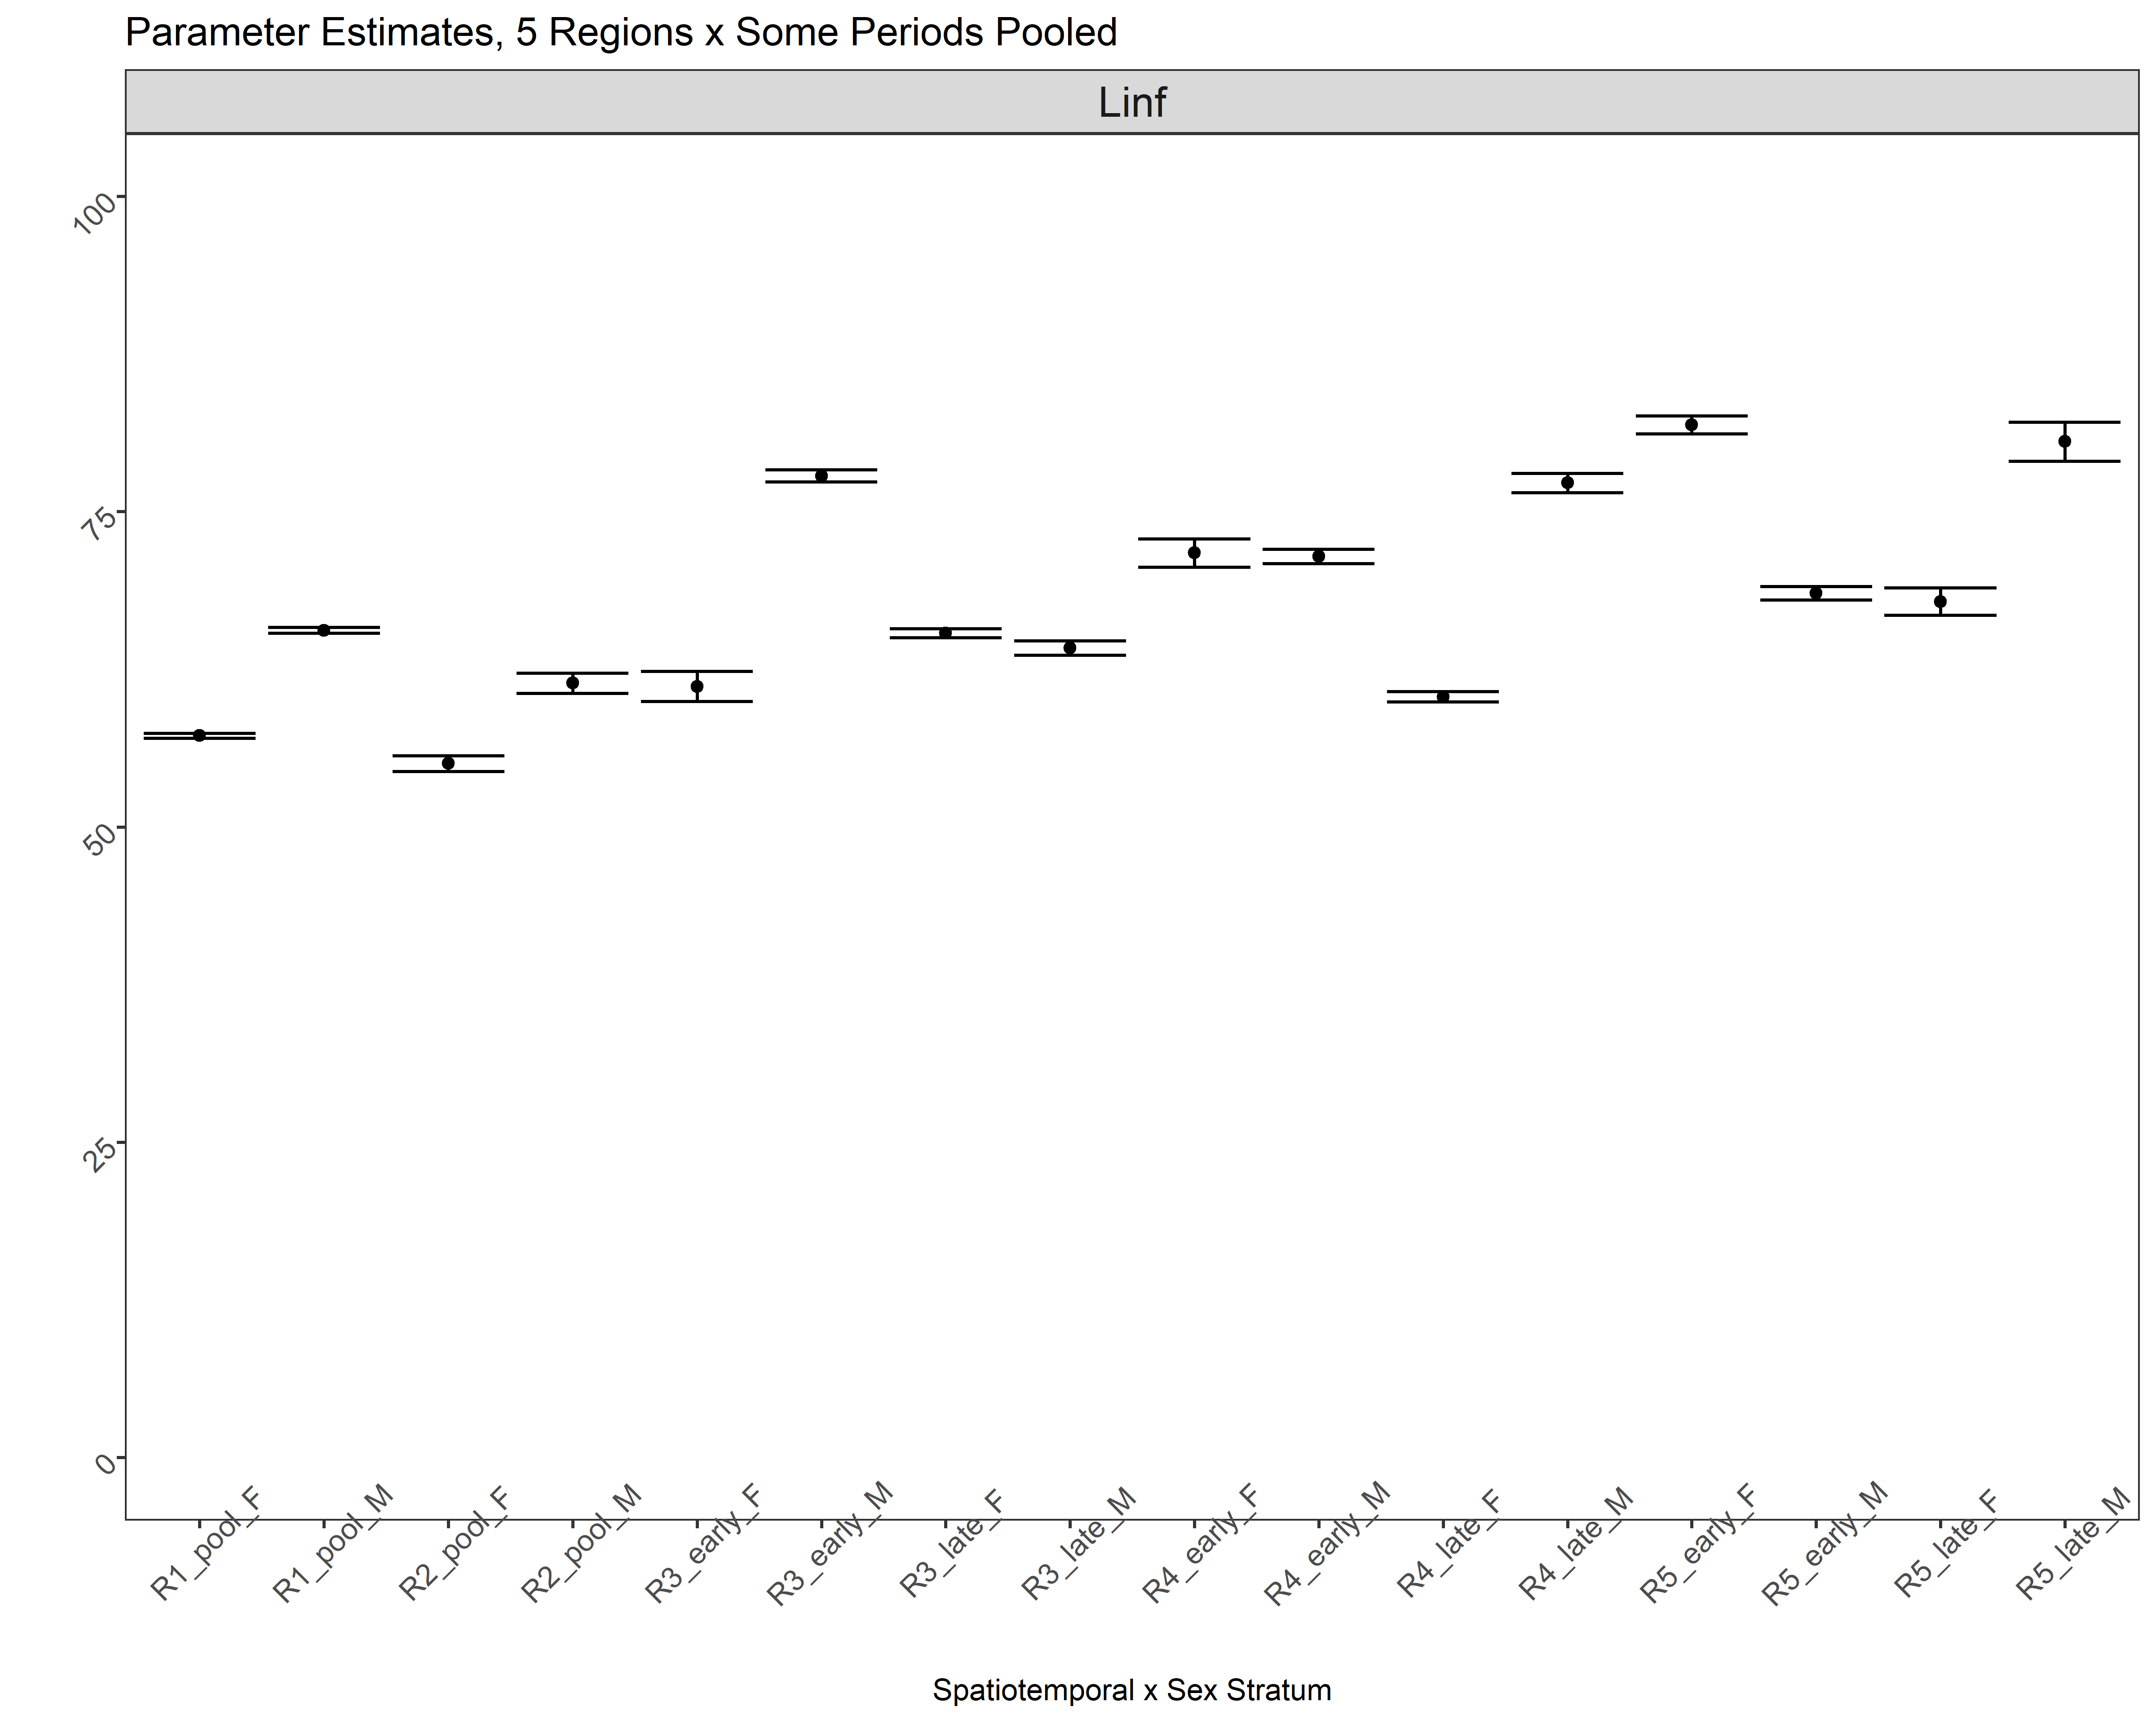

Figure A14 *L∞* estimates for the second (final) aggregation phase, where a time break at 2010 was only applied to both sexes for regions 3, 4 and 5; regions one and 2 use data for all years combined yet estimate sexes separately. Bars represent 95% confidence intervals.